Introduction to Probability for Machine learning
Every learnable or data based mathematical model in this world has the probabilistic interpretation or intuition behind it. Almost all machine learning or deep learning models have the same property. Great knowledge of probability is something which can allow you to understand every machine learning concept. Even most of the latest ML advancements like GANS, Auto-encoders were developed with great probabilistic intuitions. Since it is at most required to understand probabilistic interpretation of all standard ML models, we definitely need some good concept of Probability.
At its core, probability is a measure of the likelihood that a particular event will occur. It provides a formal framework for dealing with uncertainty and randomness. In the realms of data science and machine learning, probability plays a pivotal role, acting as a guiding light to make informed decisions and predictions.
**Why is Probability Important in Data Science and Machine Learning?**
1. **Uncertainty Quantification:**
- *In Data Science:* Real-world data is inherently uncertain and often contains noise. Probability allows us to quantify and model this uncertainty, providing a more realistic representation of the data.
- *In Machine Learning:* Probability helps in assessing the confidence level of predictions. For example, a classifier may not only predict the class of an object but also provide a probability score, indicating the model's confidence in the prediction.
2. **Statistical Inference:**
- *In Data Science:* When drawing conclusions from data, statistical inference relies heavily on probability. Confidence intervals and hypothesis testing are examples of statistical tools that leverage probability to make statements about the underlying population based on sample data.
- *In Machine Learning:* Understanding the distribution of data and making inferences about the entire dataset based on a sample are crucial aspects. Probability provides the foundation for these statistical techniques.
3. **Decision Making under Uncertainty:**
- *In Data Science:* Decision-making processes often involve uncertainty. Probability aids in making rational decisions by assessing the likelihood of different outcomes.
- *In Machine Learning:* Models, especially in classification and regression tasks, output predictions along with associated uncertainties. This information is valuable in scenarios where decisions based on predictions carry inherent risks.
4. **Bayesian Inference:**
- *In Data Science:* Bayesian methods allow us to update our beliefs about a hypothesis as new evidence is acquired. Probability is at the heart of Bayesian inference, facilitating a flexible and principled approach to modeling uncertainty.
- *In Machine Learning:* Bayesian models provide a coherent framework for incorporating prior knowledge into the learning process. This is particularly useful in situations with limited data.
5. **Modeling and Prediction:**
- *In Data Science:* Probability distributions are used to model the variability in data. This is crucial for creating accurate and reliable models.
- *In Machine Learning:* Many machine learning algorithms, especially those in the probabilistic modeling domain, leverage probability distributions to make predictions. Bayesian networks, Gaussian processes, and probabilistic graphical models are examples of such techniques.
In essence, probability is the cornerstone that transforms uncertainty into a structured and quantifiable form. Its integration into data science and machine learning methodologies enhances the robustness, interpretability, and reliability of models, making them powerful tools for extracting meaningful insights from complex and uncertain data landscapes.
Let’s set some terms right first:-
Sample space(S) :- Set of all possible outcomes for an experiment. for eg:- experiment: flipping a coin , S1- {H,T} , exp: rolling dice ,S2- {1,2,3,4,5,6}.
Event(E) :- Any subset E of sample space S. E1- {H} of S1(only head), E2 = {2,4,6}(only even outcome of dice)
EUF :- New event EUF is defined when to consist events of S which are present in E or F or in both. eg:- E = {1,2}, F = {3,4}: EUF = {1,2,3,4}.
E∩F :- New event E∩F is defined when to consist events of S which are present both in E and F. eg:- E = {1,2,},F = {2,3}: E∩F = {2}.If E∩F = Φ ,then E and F are considered mutually exclusive event.
Unions:- If E1,E2 ……En are events,then union of these events Union(E1,….En) is defined to be a event that consists of all outcome in Ei for at least one value of i = {1,2,3…..n).
Intersections:- If E1,E2 ……En are events, then intersection of these events Intersection(E1,….En) is defined to be a event that consists of all outcome in Ei for at all values of i = {1,2,3…..n).
E^c(compliment of E):- Event which consist of all outcomes of S which is not present in E.
EUE^c = S, E∩F = Φ, S^c = Φ
For event E in S,P(E) is denoted as probablity of occuring of event E in S where it follow some axioms:-
- 0 ≤ P(E) ≤ 1
- P(S) = 1
- for mutually exclusive events P(union of all E) = sum(P(Ei’s) and P(intersection of all E) = 0
P(S) = 1 => P(EUE^c) = 1 => P(E) + P(E^c) = 1 => P(E^c) = 1-P(E)
If E and F are not mutually exclusive: - P(E) + P(F) = P(EUF) + P(E∩F)
1.P(EUF) = P(E) + P(F)- P(E∩F)
2.P(E ∪ F ∪ G)
= P(E) + P(F) − P(EF) + P(G) − P(EG ∪ FG)
= P(E) + P(F) − P(EF) + P(G) − P(EG) − P(FG) + P(EGFG)
= P(E) + P(F) + P(G) − P(EF) − P(EG) − P(FG) + P(EFG)
Finally, from above patterns, we can obtain a formula: -
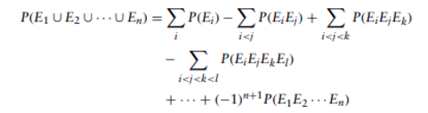

Conditional Probability
Let E and F be two events, then conditional probability that E will occur given that F is already occurred is denoted by P(E|F). Lets understand it with an example.
We calculate P(E/F) = P(E∩F)/P(F) i.e conditional probability of E given F has occured = Probability of intersection of E and F(EUF) relative to probability of F.i.e P(E∩F) = P(E/F)*P(F)
Let’s understand with example, Find probability that sum of outcome of two dice when rolled is 6 given first dice comes out as 4.
S = ({4,1},{4,2},{4,3},{4,4},{4,5},{4,6}), E = {4,2} , so P(E) = 1/6
solving same with conditional probability = P(E∩F)/P(F),so,
P(E∩F) = Probability of sum : 6 and first dice : 4 = P({4,2}) = 1/36
P(F) = Probability of first dice : 4 = P({4,1},{4,2}….{4,6}) = 6/36
P(E/F) = (1/36)/(6/36) = 1/6
P(E/F) = P(E∩F)/P(F) => P(E∩F) = P(E/F)*P(F)
Independent Events :- Two events E and F are said to be independent if P(E∩F) = P(E)*P(F).i.e -> P(E/F) = P(E), other wise they are called dependent events.
The events E1,E2,E3,…..En are called independent if for every subset E1,E2 …Er ,r ≤ n, of these events
P(E1E2……Er) = P(E1).P(E2).P(E3)………………………P(Er)
Pairwise independent events are not needed to be independent among themselves.
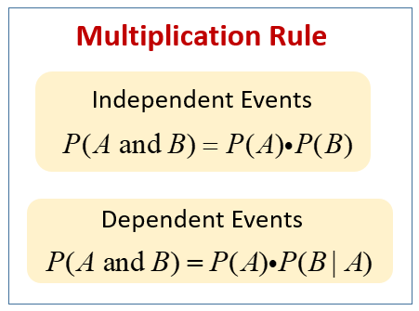

Chain rule
The conditional probability rule defined above for two events P(E∩F) = P(E/F)*P(F) can be extended for more than two events,for example, for four events A1,A2,A3,A4 it can be written as
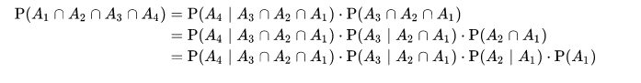
For n events it can be generalized to:-
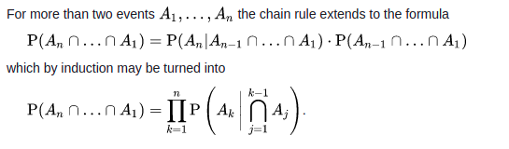

Random Variable
The real values function defined on sample space is called random variable.
Example: - Let X denote a random variable that is defined as sum of two fair dice rolled together, => P(X=2) = P({1,1}) = 1/36, P(X=5) = P({1,4},{2,3},{3,2},{4,1}) = 1/9 = 4/36
Example:- Lets suppose we toss a coin having probability p for coming up heads after N flips resulted in tail. Define random variable N;-
P(N=0) = N.A (0 times toss)
P(N=1) = p (first time head)
P(N=2) = (1-p).p(head after 1 tail)
P(N=3) = (1-p)².p(head after 2 tails)
P(N=n) = ((1-p)^n-1).p(head after n-1 tails)
Discrete random Variable: - Random Variable defined on finite or countable i.e discrete possible set of values from sample space like examples above are called discrete random variable. examples given above are of discrete r.v .
Continuous Random Variable: - Random Variables defined on continuum of possible values i.e range of values contaning infinite elements between are called continuous random variable.example:- random variable X denoting lifetime of car,P(X ≥ 3) or P(2 ≤ X ≤ 10).
Cummulative Distribution function:- It is the distribution function(F.) of the random variable X defined for any real no. b, where b lies from -inf to inf , (inf = infinity), such that F(b) = P(X ≤ b).
CDF F is defined as F(b) denotes probability that the random variable X takes on a value that is less than or equal to b.It can also be understood as F(b) is sum of all probabilities P(X) where X≤ b.
CDF can be answer to many probability question about X,like :-
P(a ≤ X ≤ b) = F(b)-F(a).
Some properties a cdf follow:-
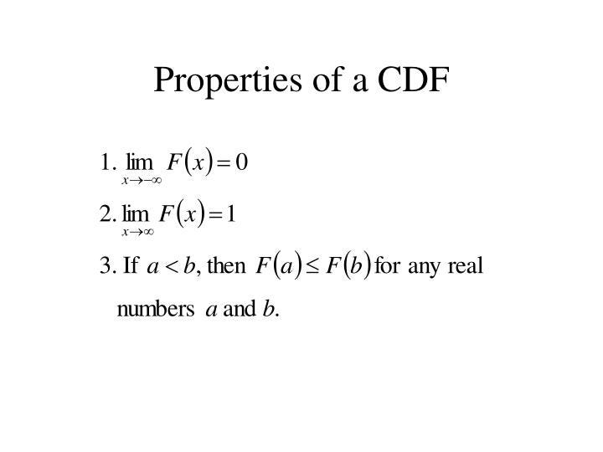
I mean,these rules are obvious,since cdf F(a) means probability that a random variable’s value is upto max a,so if a is inf,random variable can cover value upto inf,so F(a) = 1 similarly second rule and for the third,if b > a,F(b) means R.V has covered all value upto b even a,and after a also upto b,so F(b) > F(a).
A random variable in probability theory is a variable that takes on different values based on the outcome of a random event or experiment. It represents an uncertain quantity or outcome and is typically denoted by a capital letter, such as X.

A random variable can be either discrete or continuous.

Discrete Random Variable: A discrete random variable can only take on a countable set of distinct values. Examples include the number of heads obtained in multiple coin flips or the number of cars passing through a toll booth in a given time period.

Continuous Random Variable: A continuous random variable can take on any value within a certain range or interval. Examples include the height of individuals, the time it takes for a process to complete, or the temperature measured at a specific location.

In both cases, the random variable is associated with a probability distribution that describes the likelihood of each possible value occurring. The probability distribution can be represented using a probability mass function (PMF) for discrete random variables or a probability density function (PDF) for continuous random variables.

By studying the properties and behavior of random variables, we can analyze and make predictions about the outcomes of random events and calculate various statistical measures such as mean, variance, and probability.
Discrete Random Variable
As ,discussed discrete random variable is random variable defined on countable/discrete set of values.
For a discrete random variable X, a Probability Mass Function(pmf) P(a) is defines Probability that the value of random variable X = a,i.e pmf(a) = P(X=a).
The cumulative distribution function F for a discrete random variable can be defined as the sum of its probability mass function.
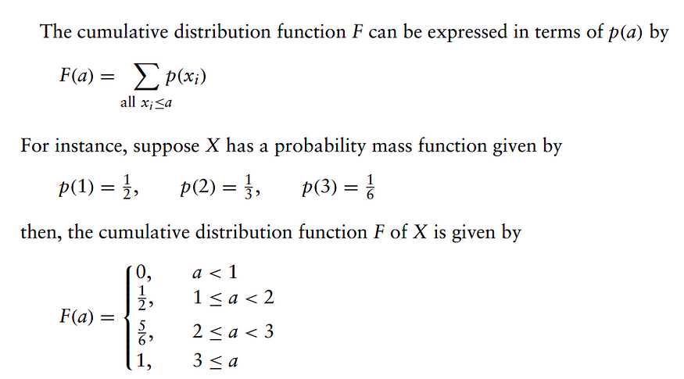

The Bernoulli Random Variable
Suppose that a trial, or an experiment, whose outcome can be classified as either a “success” or as a “failure” is performed. If we let X equal 1 if the outcome is a success and 0 if it is a failure, then the probability mass function of X is given by
p(0) = P(X = 0) = p
p(1) = P(X = 1) = 1-p
The random variable following this equation is called bernoulli random variable.

The Binomial Random Variable
Suppose that n independent trials, each of which results in a “success” with probability p and in a “failure” with probability 1 − p, are to be performed. If X represents the number of successes that occur in the n trials, then X is said to be a binomial random variable with parameters (n, p). The probability mass function of a binomial random variable having parameters (n, p) is given by
The probability mass function of a binomial random variable having parameters (n, p) is given by
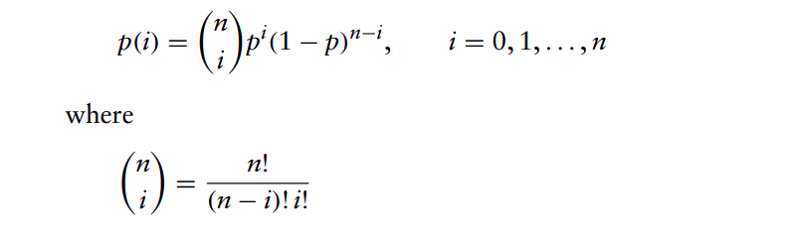

The Geometric Random Variable
Suppose that independent trials, each having probability p of being a success, are performed until a success occurs. If we let X be the number of trials required until the first success, then X is said to be a geometric random variable with parameter p. Its probability mass function is given by

The Poisson Random Variable
A random variable X, taking on one of the values 0, 1, 2, … , is said to be a Poisson random variable with parameter λ, if for some λ > 0,


Continuous Random variable
Let X be such a random variable. We say that X is a continuous random variable if there exists a nonnegative function f(x), defined for all real x ∈ (−∞,∞), having the property that for any set B of real numbers
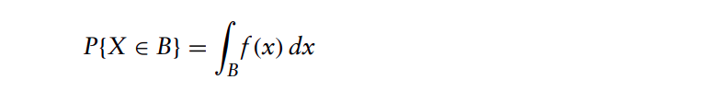
here f(x) is called the probability density function for a random variable x. It can be compared with probability mass function of discrete case.
Probability density function(pdf) can be defined as a function of a continuous random variable, whose integral across an interval gives the probability that the value of the variable lies within the same interval.
The integral of pdf from −∞ to a value b gives the probability of random variable to be ≤ b and is what we call as cummulative distribution function(cdf).
The probability of X between a range can be obtained by integral of pdf over that range.
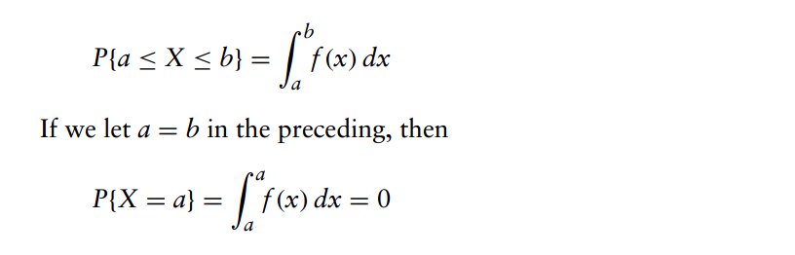
The a=b equation clarifies that probability that a continuous random variable will assume a particular value is 0.

The Uniform Random Variable
X is a uniform random variable on the interval (α, β) if its probability density function is given by
A random variable is said to be uniformly distributed over the interval (0, 1) if its probability density function is given by
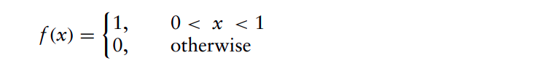

Exponential Random Variables
A continuous random variable whose probability density function is given, for some λ > 0, by
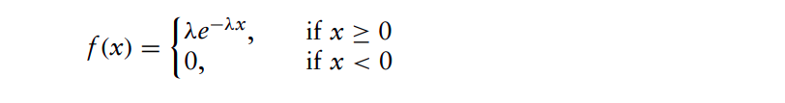
is said to be an exponential random variable with parameter λ
The cdf of exponential random variable can be calculated as
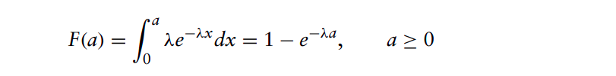

Gamma Random Variables
A continuous random variable whose density is given by
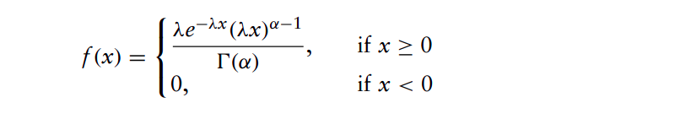
for some λ > 0, α > 0 is said to be a gamma random variable with parameters α, λ.
The quantity (α) is called the gamma function and is defined by
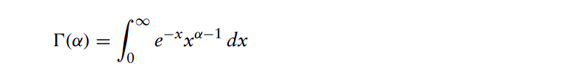

Normal Random Variables
X is a normal random variable (or simply that X is normally distributed) with parameters μ and σ2 if the density of X is given by

This density function is a bell-shaped curve that is symmetric around μ
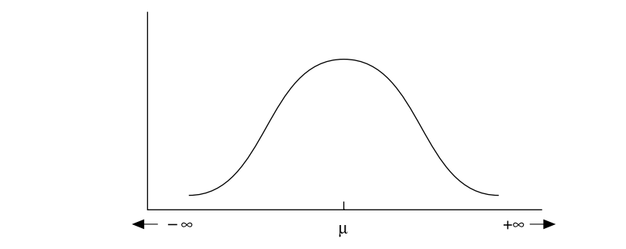
An important fact about normal random variables is that if X is normally distributed with parameters μ and σ2 then Y = αX + β is normally distributed with parameters αμ + β and α2σ2.This can be proved easily as:-
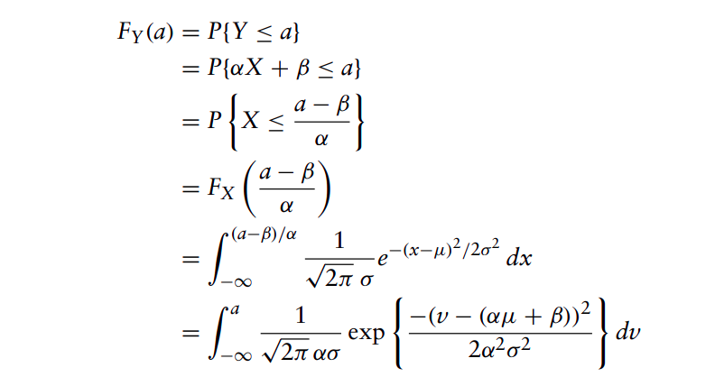
where the last equality is obtained by the change in variables v = αx + β.

Expectation of Random Variable

The expectation of a random variable is a measure of its average or expected value. It represents the average value that the random variable would take over a large number of trials or observations.

Mathematically, the expectation of a discrete random variable X is denoted as E(X) or μ (mu) and is calculated as the sum of the product of each possible value of X and its corresponding probability:

E(X) = Σ(x * P(X = x))

Where x represents the possible values of X, P(X = x) represents the probability of X taking the value x.

For a continuous random variable, the expectation is calculated using integration instead of summation. The expectation of a continuous random variable X with probability density function f(x) is denoted as E(X) or μ (mu) and is calculated as:

E(X) = ∫(x * f(x)) dx

The expectation is a fundamental concept in probability and statistics and provides important insights into the central tendency or average behavior of a random variable. It can be used to analyze and compare different random variables, estimate population parameters, and make predictions based on probabilistic models.
Expectation of a random variable X is a weighted average of the possible values that X can take on,each value being weighted by the probability that X assumes that value.
Discrete case:- If X is a discrete random variable having a probability mass function p(x), then the expected value of X is defined by
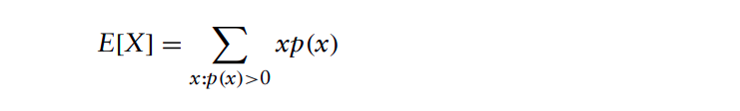
Find E[X] where X is the outcome when we roll a fair die.
Since p(1) = p(2) = p(3) = p(4) = p(5) = p(6) = 1/6 , we obtain E[X] = 1( 1 /6 ) + 2( 1/6 ) + 3( 1/6 ) + 4( 1/6 ) + 5( 1/6 ) + 6( 1/6 ) = 7/2
Expectation of a Bernoulli Random Variable:- E[X] = 0(1 − p) + 1(p) = p
Expectation of a Binomial Random Variable:-
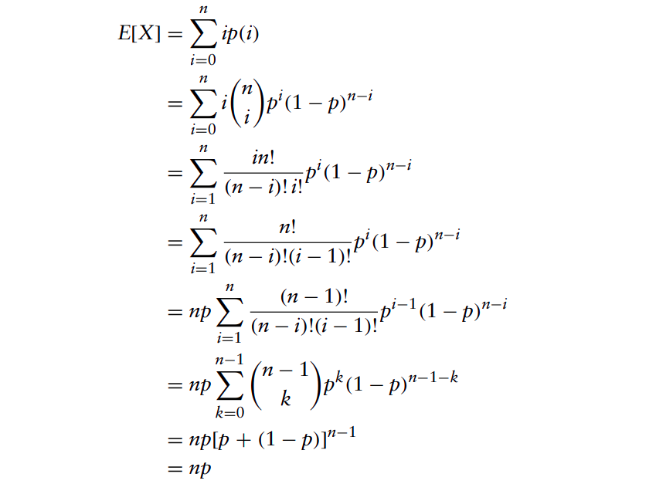
similarly, expectations of rest discrete random variables can be created
Continuous case:- If X is a continuous random variable having a probability density function f(x), then the expected value of X is defined by

Expectation of a Uniform Random Variable: -
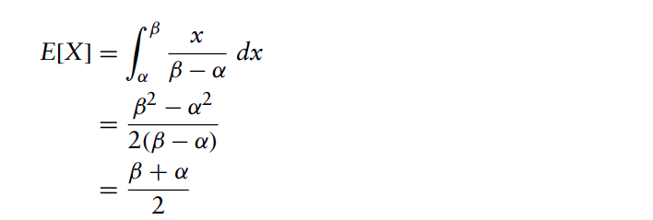
Expectation of a Normal Random Variable:-

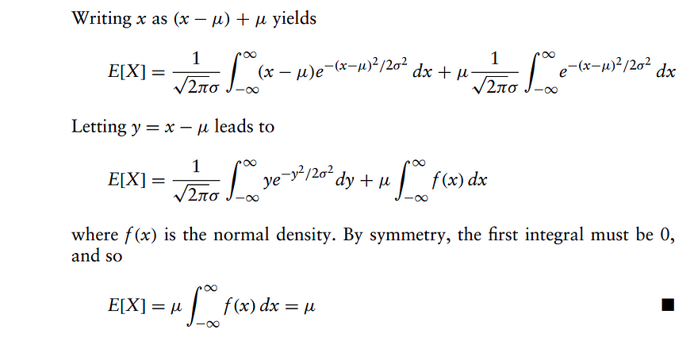

Expectation of function of random variable
We now know how to calculate expectation of a random variable function, but we also need to study about expectation of function of random variable. It will again depend on if X is discrete or continuous random variable.
- If X is a discrete random variable with probability mass function p(x), then for any real-valued function g,

example:- Suppose X has the following probability mass function: p(0) = 0.2, p(1) = 0.5, p(2) = 0.3, calculate E[X²]
E[X2] = 02(0.2) + (12)(0.5) + (22)(0.3) = 1.7
2. If X is a continuous random variable with probability density function f(x), then for any real-valued function g,

example:- Let X be uniformly distributed over (0, 1). Calculate E[X3].
(since f(x) = 1, 0 < x < 1)
E[X3] = ∫X³.1.dx(from 0 to 1) = [X⁴/4](0 to 1) = 1/4
The expected value of a random variable X, E[X], is also referred to as the mean or the first moment of X. The quantity E[X^n], n ≥ 1, is called the nth moment of X.
Variance:- The variance of X measures the expected square of the deviation of X from its expected value.It is given as:-
Var(X) = E [(X − E[X])]²
we can use above formula to calculate variance of any distribution.

Jointly Distributed Random Variables
We have studied concepts regarding a single random variable X,however in real life a distribution may depend on multiple random variable so we derive concepts of jointly distributed random variable.
For any two random variables X and Y, the joint cumulative probability distribution function of X and Y is given by,
F(a, b) = P{X ≤ a, Y ≤ b}, −∞ < a, b < ∞
The distribution of X can be obtained from the joint distribution of X and Y as follows:
FX(a) = P{X ≤ a} = P{X ≤ a, Y < ∞} = F(a,∞)
FY(b) = P{Y ≤ b} = F(∞, b)
In the case where X and Y are both discrete random variables, it is convenient to define the joint probability mass function of X and Y by
p(x, y) = P{X = x, Y = y}
The probability mass function of X may be obtained from p(x, y) by
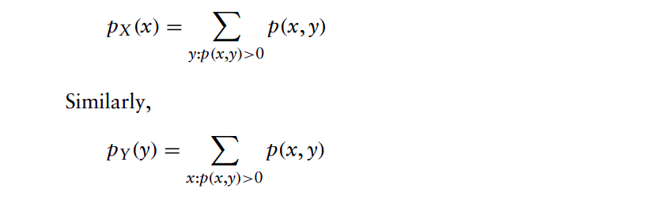
We say that X and Y are jointly continuous if there exists a function f(x, y), defined for all real x and y, having the property that for all sets A and B of real numbers
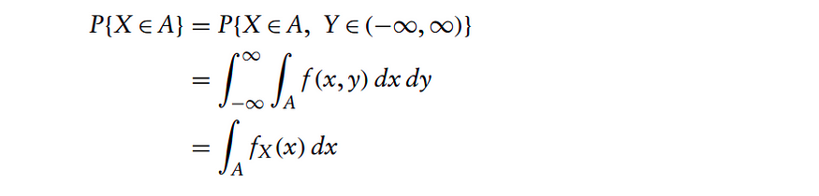


Expectation of jointly distributed random variable:-
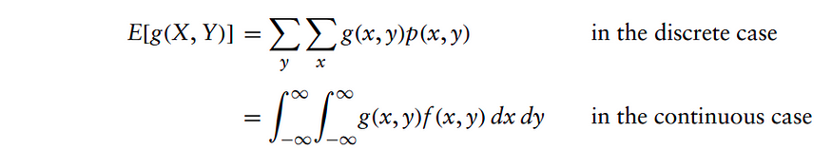
For example, if g(X, Y) = X + Y, then, in the continuous case,
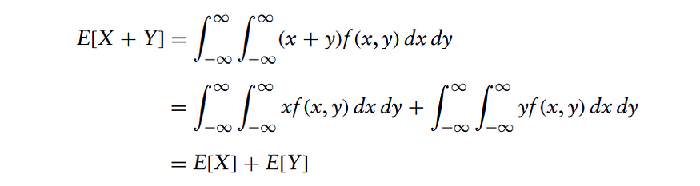
E[a1X1 + a2X2 +···+ anXn] = a1E[X1] + a2E[X2]+···+ anE[Xn]

Independent Random Variables
The random variables X and Y are said to be independent if, for all a, b,
P{X ≤ a, Y ≤ b} = P{X ≤ a}P{Y ≤ b}
In terms of the joint distribution function F of X and Y, we have that X and Y are independent if
F(a, b) = FX(a)FY(b) for all a, b
When X and Y are discrete, the condition of independence reduces to
p(x, y) = pX(x)pY(y)
while if X and Y are jointly continuous, independence reduces to
f(x, y) = fX(x)fY(y)
i.e the joint pdf or pmf of {X,Y} is the product of their repsective pdf or pmf.
If X and Y are independent, then for any functions h and g
E[g(X)h(Y)] = E[g(X)]E[h(Y)]

Covariance
The covariance of any two random variables X and Y, denoted by Cov(X, Y), is defined by
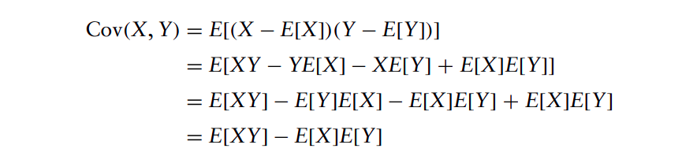
Cov(X, Y) = E[XY] − E[X]E[Y]

Properties of Covariance
For any random variables X, Y, Z and constant c,
- Cov(X, X) = Var(X)
- Cov(X, Y) = Cov(Y, X)
- Cov(cX, Y) = c Cov(X, Y)
- Cov(X, Y + Z) = Cov(X, Y) + Cov(X, Z).

Bayes Theorem
We all now know about conditional probability
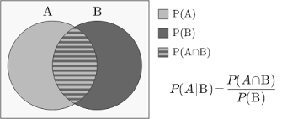
So, P(A∩B) = P(A/B)*P(B)
we can say P(A∩B) = P(B∩A),so it can be written as
:-> P(A ∩ B) = P(A)P(B|A) , P(A ∩ B) = P(B)P(A|B)
:-> P(B)P(A|B) = P(A)P(B|A)
P(A|B) = (P(A)* P(B|A))/P(B)
This is what we call as Bayes theorem
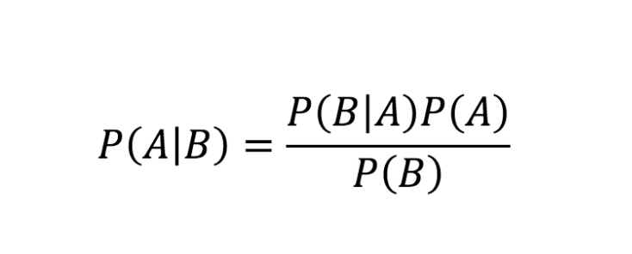
Now we can make bayes theorem more applicable and general purpose by operating on P(B) i.e denominator.
Let A and Bbe events. We may express B as :- B= BA ∪ BA^c
P(B) = P(BA) + P(BA^c) -> P(B) = P(B|A)P(A) + P(B|A^c)P(A^c)
So,the bayes theorem now can be modified to this formula
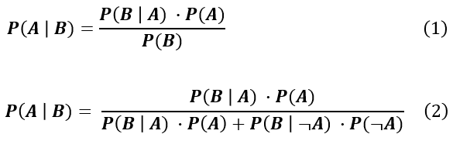
Now,suppose B is dependent on more than 2 events,i.e like A and ~A,let it be n events(A1,A2…..An). In this case, the formula can be further generalized to
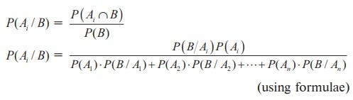
This is the general purpose bayes formula :-
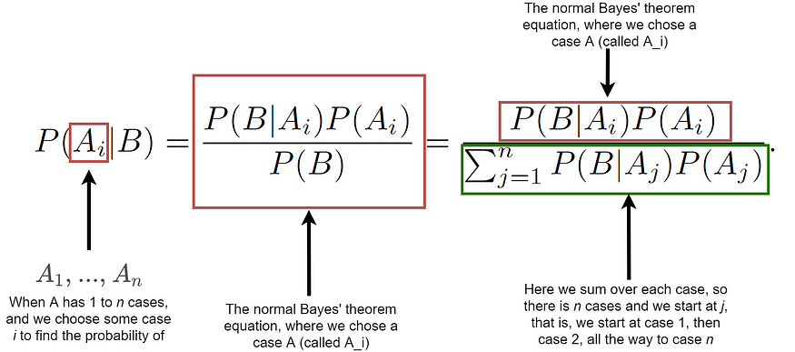

Likelihood
The distinction between probability and likelihood is fundamentally important: Probability attaches to possible results; likelihood attaches to hypotheses.
Well,we are not philosophical mathematicians,so we tend understand things better with simple examples.So,lets understand the thing with help of an example.
Let their be random variable X with pdf as normal(gaussian) function,with parameter θ →{μ,σ}.so given θ,pdf of X can be written as P(X|θ) = N(μ,σ).
So,The probability function(pdf in continuous case and pmf in discrete) is represented by P(X|θ) predicting probability distribution given hypothetis or parameter (call it anything) , similarly, likelihood function is represented by L(θ|X) predicting parameters or hypothesis given the probability distribution.
Well both are different things,one predicts result while other hypothesis,we need not think much about it and confuse us too much,just know one thing that both are equivalent and used equivalently,so we can replace one with other in our field of study.
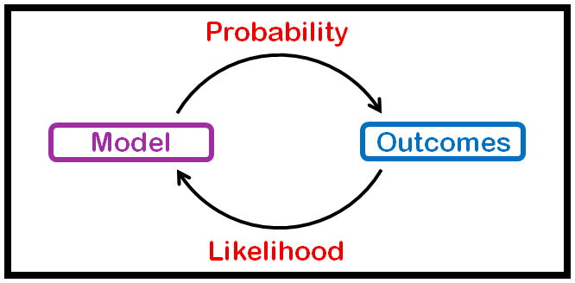
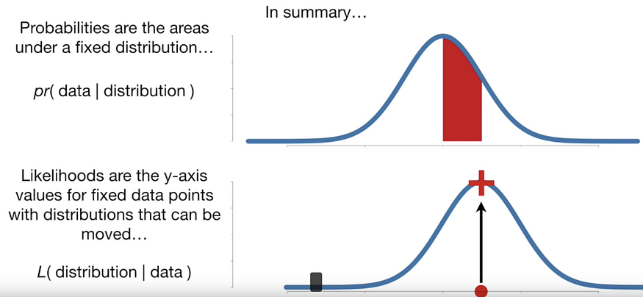
L(θ|X) →P(X|θ) (both are equivalent) and have same impact
where f is pdf or pmf of the distribution.
Lets redefine bayes theorem now:-
bayes theorem:- P(β∣y) = P(y∣β) x P(β) / P(y)
redefined with likelihood => P(β∣y) = L(β|y) x P(β) / P(y), the term P(y|β) is equivalent to L(β|y).
We are trying to write a distribution describing probability of β given y,here y is given as an evidence,we assume we have prior knowledge about β so that we can write function about it with evidence,the term P(y|β) is equivalent to L(β|y) i.e likelihood. we like to call P(β|y) as posterior.
now let’s write the formula in english
posterior = likelihood * prior / evidence, this is another important analogy of bayes theorem,it help us to predict probability of event given it’s prior knowledge, evidence and likelihood.
Story 1:
Once upon a time in a village in India, there were two friends - Raj and Priya. Raj loved figuring out how likely something was to happen, while Priya was great at understanding the chances of events.
One day, the villagers found mysterious footprints, and they asked Raj to help. Raj thought about different animals in the area and how likely each one was to make those footprints. He focused on how likely something was to happen given a certain situation.
On the other side of the village, there was a festival, and Priya was helping with a lottery. She calculated the chances of winning for each person by looking at the total number of winning tickets and all the tickets together. Priya was interested in the overall chance of something happening.
Later, the villagers wanted to know the chance of seeing a rare bird in the jungle. Priya used her math skills to figure it out based on past data, while Raj looked at the likelihood of spotting the bird in different situations.

As the villagers listened to Raj and Priya, they learned that likelihood was about chances given certain conditions, while probability was about the overall chance of an event. Both Raj and Priya helped the villagers understand and deal with uncertainties in their village.
And so, Raj and Priya continued to help their village, showing everyone the importance of looking at evidence and considering the chances of events happening. The village thrived, thanks to the unique skills of Raj and Priya.
Story 2:
In a bustling town in India, there lived two siblings named Aryan and Anika. Aryan was like a detective; he loved gathering clues and figuring out how likely something was to occur. Anika, his sister, was a master at understanding overall chances and predicting outcomes.
One day, a big event was planned in their town, and the townsfolk were eager to know if it would be a success. Aryan, with his likelihood approach, observed the preparations and assessed the factors that could influence the event. He thought about how likely different scenarios were to happen during the festivities.
Meanwhile, Anika was helping organize a game at the event. It involved picking colored marbles from a bag, and people could win prizes based on the colors they chose. Anika, with her probability expertise, calculated the overall chances of winning each type of prize. She looked at the big picture and analyzed the entire set of possibilities.
As the event unfolded, a sudden rain shower surprised everyone. Aryan, with his likelihood mindset, quickly assessed the chances of rain based on the clouds he had observed earlier. Anika, on the other hand, had already calculated the probability of rain disrupting the event, considering historical weather data.
The townsfolk, amazed by Aryan and Anika's skills, realized the difference between likelihood and probability. Aryan focused on specific situations, while Anika considered the broader outlook. Together, they provided a comprehensive understanding of uncertainties, making the town better prepared for future events.
And so, Aryan and Anika continued to complement each other's skills, ensuring that their town thrived with a balanced perspective on likelihood and probability.
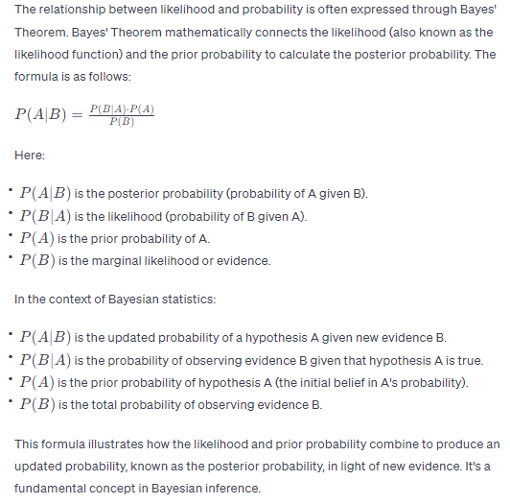
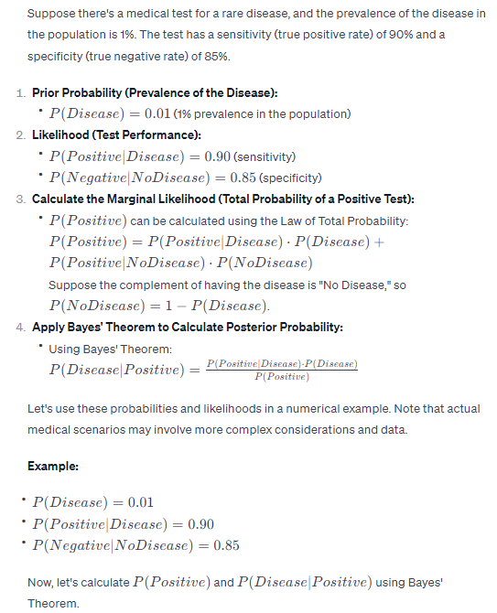
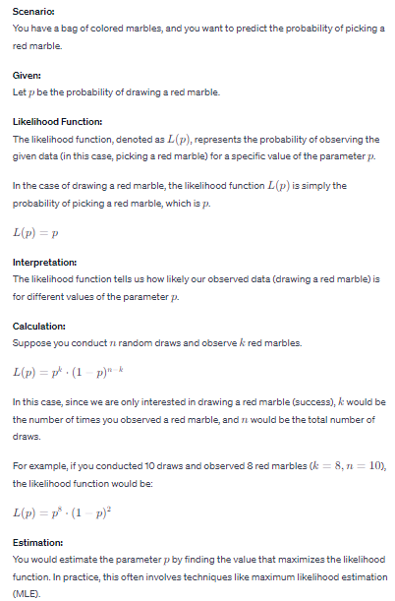
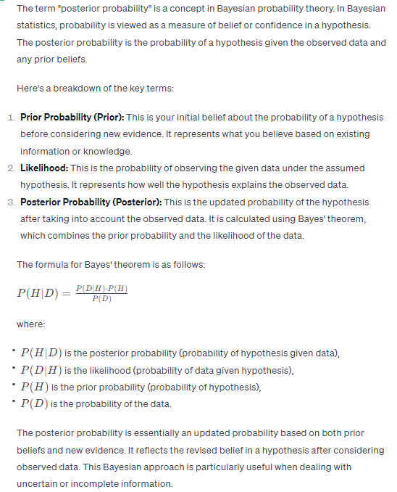
The posterior probability is the probability an event will occur in any case evidence or background statistics have been taken into consideration. It is intently associated with prior probability, that’s the probability an event will manifest before you take any new proof into consideration. Here, in this article, we will discuss the posterior probability in detail.

Definition of Posterior Probability
A posterior probability is the updated probability of some event occurring after accounting for new data. As an instance, we might be inquisitive about locating the probability of a few event “A” going on once we account for a few event “B” that has simply taken place.

The formula for calculating posterior probability
We should calculate this posterior probability via the usage of the following formulation :
P(A|B) = P(A) * P(B|A) / P(B)
Where,
- P(A|B) = the probability of event A happening, given that event B has occurred. Note that “|” refers to “given.”
- P(A) = the probability of event A that occurred.
- P(B) = the probability of event B that occurred.
- P(B|A) = the probability of event B happening, given that event A has happened.
OR
Posterior probability = prior probability + new evidence (called likelihood).

Examples of posterior probability
Suppose there is a college having 60% boys and 40% women as college students. The women put on trousers or skirts in the same numbers; all boys put on trousers. An observer sees a (random) student from a distance; all the observer can see is this student is sporting trousers. What’s the probability this scholar is a lady? The best answer can be computed with the usage of Bayes’ theorem.
The event G is that the student observed is a girl, and the event T is that the scholar located is wearing trousers. To compute the posterior probability P(G|T), we first need to realize:
- P(G), or the probability that the pupil is a woman irrespective of any other information. Because the observer sees a random scholar, which means that all college students have the same probability of being discovered, and the proportion of girls among the various college students is 40%, this possibility equals 0.4.
- P(B), or the chance that the student isn’t always a female (i.e. a boy) irrespective of another record (B is the complementary event to G). that is 60%, or 0.6
- P(T|G), or the probability of the pupil carrying trousers for the reason that the student is a girl. As they are as possible to wear skirts as trousers, this is 0.5.
- P(T|B), or the probability of the pupil wearing trousers given that the pupil is a boy. This is given as 1.
- P(T), or the probability of a (randomly selected) student sporting trousers irrespective of another record. Considering that P(T)=P(T|G)P(G)+P(T|B)P(B) (via the regulation of general probability), that is P(T)=0.5 × 0.4+1 × 0.6=0.8
Given all these statistics, the posterior probability of the observer having noticed a lady given that the found pupil is carrying trousers can be computed by using substituting these values in the formula –
P(G|T) = P(T|G) P(G)/ P(T) = 0.5 × 0.4/ 0.8
= 0.25
An intuitive way to clear up this is to anticipate the faculty has N college students. Range of boys = 0.6N and quantity of girls = 0.4N. If N is satisfactorily huge, the general variety of trouser wearers = 0.6N+ 50% of 0.4N. And a number of women trouser wearers = 50% of 0.4N. therefore, within the population of trousers, ladies are (50% of 0.4N)/(0.6N+ 50% of 0.4N) = 25%. In different words, if you separated out the institution of trouser wearers, 1 / 4 of that group will be girls. Consequently, in case you see trousers, the maximum you could deduce is that you are searching at a single sample from a subset of students where 25% are girls. And with the aid of definition, the chance of this random pupil being a girl is 25%. Each Bayes theorem hassle can be solved in this manner.
The posterior probability is important as it will help in calculating the interval estimates for the parameters, prediction inference for future data, and point estimates for the parameter.
The computational challenge is that joint distribution cannot be marginalized as the integral sum cannot be traced. In that case, the method is used by drawing the Monte Carlo samples from the posterior probability. There are multiple methods to find the posterior distribution. The method is called the vibrational inference method. The posterior distribution consists of two different sources of information. They are – information produced before observing the data and information which is provided by the data.

Conclusion
A posterior probability, in Bayesian data, is the revised or updated possibility of an event occurring after taking into account new records. The posterior probability is calculated by updating the prior possibility with the use of Bayes’ theorem. Here, we have discussed the formula for calculating the posterior probability. The discussion of the posterior probability has been discussed with examples for a better understanding of the topic. We have seen the rule of probability in the posterior probability.
A posterior probability is the updated probability of some event occurring after accounting for new information.
For example, we might be interested in finding the probability of some event “A” occurring after we account for some event “B” that has just occurred. We could calculate this posterior probability by using the following formula:
P(A|B) = P(A) * P(B|A) / P(B)
where:
P(A|B) = the probability of event A occurring, given that event B has occurred. Note that “|” means “given.”
P(A) = the probability that event A occurs.
P(B) = the probability that event B occurs.
P(B|A) = the probability of event B occurring, given that event A has occurred.

Example: Calculating Posterior Probability
A forest is composed of 20% Oak trees and 80% Maple trees. Suppose it is known that 90% of the Oak trees are healthy while just 50% of the Maple trees are healthy. Suppose that from a distance you can tell that a particular tree is healthy. What is the probability that the tree is an Oak tree?
Recall that the probability of event A occurring given that event B has occurred is:

P(A|B) = P(A) * P(B|A) / P(B)
In this example, the probability that the tree is an Oak given that the tree is healthy is:
P(Oak|Healthy) = P(Oak) * P(Healthy|Oak) / P(Healthy)
P(Oak) = The probability that a given tree is an Oak tree is 0.2 because 20% of all trees in the forest are Oak.
P(Healthy) = The probability that a given tree is healthy can be calculated as (0.20)*(0.9) + (0.8)*(0.5) = 0.58.
P(Healthy|Oak) = The probability that a tree is healthy given that it’s an Oak tree is 0.9, since we were told that 90% of the Oak trees are healthy.
Using these three numbers, we can find the probability that the tree is an Oak tree given that it’s healthy:
P(Oak|Healthy) = P(Oak) * P(Healthy|Oak) / P(Healthy) = (0.2) * (0.9) / (0.58) = 0.3103.
For an intuitive understanding of this probability, suppose the following grid represents this forest with 100 trees. Exactly 20 of the trees are Oak trees and 18 of them are healthy. The other 80 trees are Maple and 40 of them are healthy.
(O = Oak, M = Maple, Green = Healthy, Red = Unhealthy)

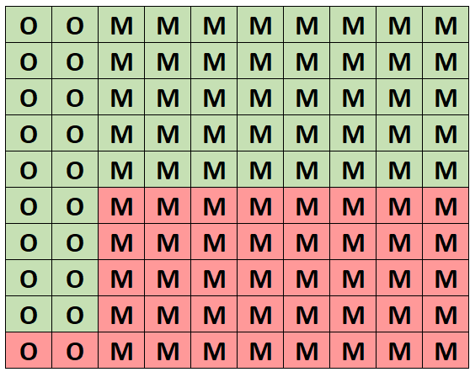
Out of all the trees, exactly 58 of them are healthy and 18 of these healthy ones are Oak trees. Thus, if we know that we’ve selected a healthy tree then the probability that it’s an Oak tree is 18/58 = 0.3103.

When Should You Use Posterior Probability?
Posterior probability is used in a wide variety of domains including finance, medicine, economics, and weather forecasting.
The whole point of using posterior probabilities is to update a previous belief we had about something once we obtain new information.
Recall in the previous example that we knew the probability of a given tree in the forest being Oak was 20%. This is known as a prior probability. If we simply picked a tree at random, we knew that the probability of it being an Oak was 0.20.
However, once we obtained the new information that the tree, we selected was healthy, we were able to use this new information to determine that the posterior probability of this tree being an Oak was instead 0.3103.
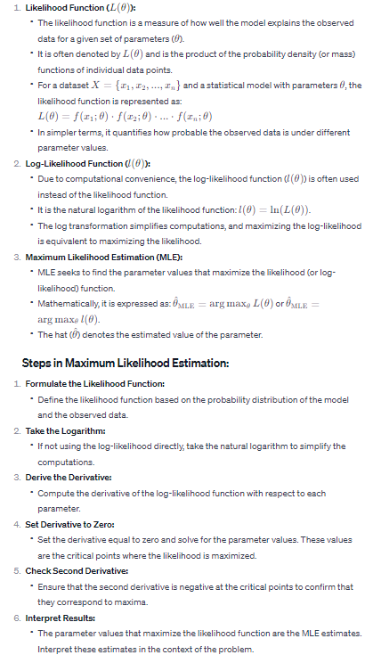
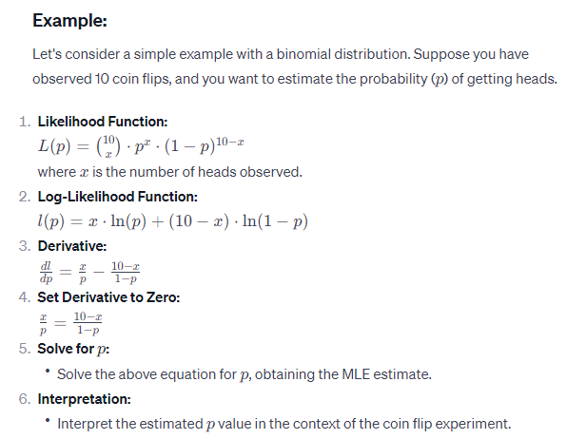

Maximum Likelihood Estimation

Once upon a time in a lively Indian village named Probabilitygram, there was a keen statistician named Raj. In Probabilitygram, they had a festival where people would gather to play a traditional game with colored bangles. Raj was intrigued by the game and wanted to figure out the likelihood of winning, specifically for the rare event of drawing a golden bangle from the bag. So, Raj organized a little game at the village fair. He handed out bags of bangles to the enthusiastic participants and asked them to draw bangles and note down the colors. The rare event they were after was drawing the coveted golden bangle. As the villagers joyfully picked bangles and recorded their colors, Raj started working on his magic – the Maximum Likelihood Estimation (MLE). He crafted a special likelihood function, a bit like a secret recipe, to calculate the probability of getting that elusive golden bangle based on the observed draws.With his trusty notebook and a bit of help from his friends, Raj went through the recorded data, plugged it into his likelihood function, and crunched the numbers. There were a few hiccups along the way – warnings that popped up like playful challenges – but Raj, determined and experienced, simply brushed them aside.After some mathematical twists and turns, Raj finally cracked the code and found the Maximum Likelihood Estimate for the probability of drawing a golden bangle. The villagers were thrilled with Raj's statistical magic, and the festival became even more exciting with everyone now understanding the odds of winning the golden bangle game. And so, Probabilitygram celebrated not just the colors of their bangles but also the magic of Maximum Likelihood Estimation!

Story 2

In the bustling Indian city of Probabilitypur, there was a renowned spice merchant named Ananya. Ananya was not just known for her flavorful spices but also for her curiosity about chance events. One day, she decided to explore the probability of a rare occurrence in her spice shop – customers winning a special discount card.

Ananya handed out cards to her customers with each spice purchase, and on these cards were the potential for a golden discount – an event as rare and precious as the finest saffron. Intrigued by the uncertainty of who would get the golden discount, Ananya embarked on a journey of probability exploration.

As customers made their purchases, Ananya diligently recorded the outcomes, noting who received the coveted golden discount. She realized that understanding the likelihood of winning this discount could make her spice shop even more exciting for her customers.

Ananya, being a savvy businesswoman, decided to use the powerful tool of Maximum Likelihood Estimation (MLE). She carefully crafted a likelihood function that captured the essence of her unique discount distribution, considering the different spice preferences of her customers.

Ignoring the occasional warning signs that popped up in her calculations, Ananya continued with determination. She inputted the data into her MLE function, making sense of the probabilities and estimating the parameter that represented the chance of winning the golden discount.

After some thoughtful calculations and a pinch of statistical magic, Ananya proudly unveiled the Maximum Likelihood Estimate for the probability of winning the golden discount. The customers were not only delighted by the flavorful spices but also by the newfound understanding of their chances to spice up their lives with a golden discount.

And so, in Probabilitypur, Ananya's spice shop became not just a place for aromatic delights but also a hub where the magic of Maximum Likelihood Estimation added a sprinkle of excitement to every purchase.

Introduction

Maximum likelihood is an approach commonly used for such density estimation problems, in which a likelihood function is defined to get the probabilities of the distributed data. It is imperative to study and understand the concept of maximum likelihood as it is one of the primary and core concepts essential for learning other advanced machine learning and deep learning techniques and algorithms.
In this article, we will discuss the likelihood function, the core idea behind that, and how it works with code examples. This will help one to understand the concept better and apply the same when needed.
Let us dive into the likelihood first to understand the maximum likelihood estimation.

What is the Likelihood?
In machine learning, the likelihood is a measure of the data observations up to which it can tell us the results or the target variables value for particular data points. In simple words, as the name suggests, the likelihood is a function that tells us how likely the specific data point suits the existing data distribution.
For example. Suppose there are two data points in the dataset. The likelihood of the first data point is greater than the second. In that case, it is assumed that the first data point provides accurate information to the final model, hence being likable for the model being informative and precise.
After this discussion, a gentle question may appear in your mind, If the working of the likelihood function is the same as the probability function, then what is the difference?

Difference Between Probability and Likelihood
Although the working and intuition of both probability and likelihood appear to be the same, there is a slight difference, here the possibility is a function that defines or tells us how accurate the particular data point is valuable and contributes to the final algorithm in data distribution and how likely is to the machine learning algorithm.
Whereas probability, in simple words is a term that describes the chance of some event or thing happening concerning other circumstances or conditions, mostly known as conditional probability.
Also, the sum of all the probabilities associated with a particular problem is one and can not exceed it, whereas the likelihood can be greater than one.

What is Maximum Likelihood Estimation?
After discussing the intuition of the likelihood function, it is clear to us that a higher likelihood is desired for every model to get an accurate model and has accurate results. So here, the term maximum likelihood represents that we are maximizing the likelihood function, called the Maximization of the Likelihood Function.
Let us try to understand the same with an example.
Let us suppose that we have a classification dataset in which the independent column is the marks of the students that they achieved in the particular exam, and the target or dependent column is categorical, which has yes and No attributes representing if students are placed on the campus placements or not.
Noe here, if we try to solve the same problem with the help of maximum likelihood estimation, the function will first calculate the probability of every data point according to every suitable condition for the target variable. In the next step, the function will plot all the data points in the two-dimensional plots and try to find the line that best fits the dataset to divide it into two parts. Here the best-fit line will be achieved after some epochs, and once achieved, the line is used to classify the data point by simply plotting it to the graph.

Maximum Likelihood: The Base
The maximum likelihood estimation is a base of some machine learning and deep learning approaches used for classification problems. One example is logistic regression, where the algorithm is used to classify the data point using the best-fit line on the graph. The same approach is known as the perceptron trick regarding deep learning algorithms.
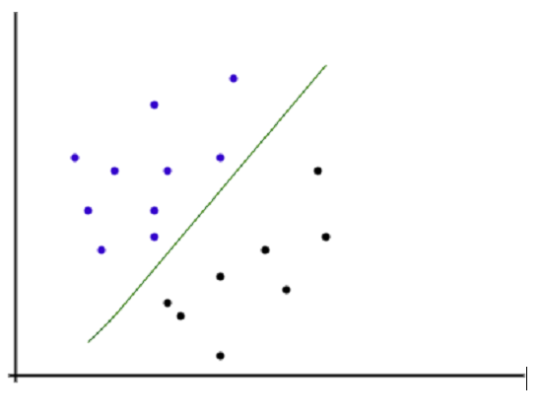
As shown in the above image, all the data observations are plotted in a two-dimensional diagram where the X-axis represents the independent column or the training data, and the y-axis represents the target variable. The line is drawn to separate both data observations, positives and negatives. According to the algorithm, the observations that fall above the line are considered positive, and data points below the line are regarded as negative data points.

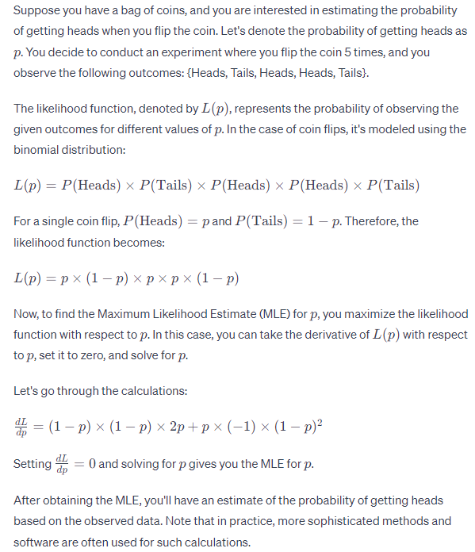
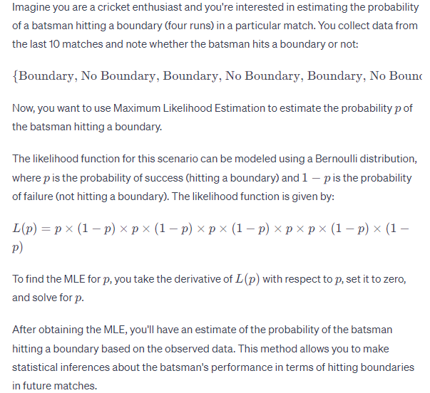
We now know about likelihood function and how it can be expressed in form of probability distribution.
For a given set of numbers or data,we want to find the perfect or best suitable distribution in form of parameters,for eg: what should be values of μ and σ to express the set of numbers as Normal distribution?
So for estimating the parameters of distribution best suitable to given set of data or numbers,we have to determine the θ i.e parameters having highest likelihood for data.
This estimation of parameters having highest likelihood value for given set of data is called maximum likelihood estimation.
The common 2 steps involved in doing MLE is:-
- We know this relation:-
so,we first writing the joint probability density or joint probability mass function for the distribution.
2. We then find the value of θ i.e parameters for which value of this joint probability distribution is maximum with calculus(for maximized argument calculation).
Lets do the maximum likelihood estimation of a general Normal(Gaussian) function having mean μ and variance σ.
so θ = {μ,σ},X = {x1,x2,x3,x4,x5……….xn}
The probability density function of a generic term of the sequence is
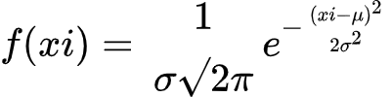
Support we have the following n i.i.d observations: x1,x2,…,xnx1,x2,…,xn. Because they are independent, we know than for independent random variables,joint probability distribution is the product of all probability distribution.i.e -> f(x1,x2..xn) = f(x1).f(x2)…….f(xn)
So,the joint probability distribution of the data is product of normal function of every data point->
Now we have to maximize this and find θ = {μ,σ} for that maximum.
Since the product form of equations are hard to handle and apply calculus,we apply log on both sides,
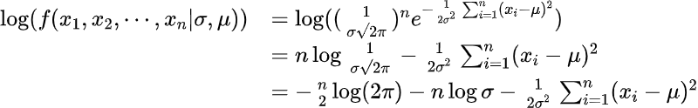
To find μ and σ for maximum of this function,we can partially differentiate this w.r.t μ and σ respectively to find it’s correct value,
Let’s call log(f(x1,x2,…,xn|σ,μ))as L then let:
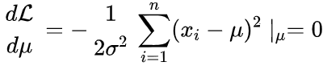
solve this equation, we get
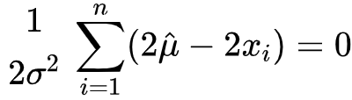
Because σ² should be larger than zero,
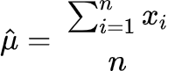
Similarly, let
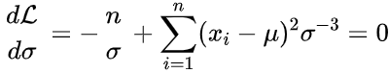
by upsolving,we get that as:-
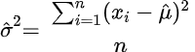
so,we got the value of μ and σ that will be best estimate for our data.
This method can be applied to any distribution,data to find best set of parameters giving best estimate for the data.
We generally calculate MLE assuming data to IID(Identical Independet dataset),so all above steps are followed:-
- Joint probability distribution is written in terms if data and parameters
- Assuming IID,it is expressed in form of product of likelihood/probability function for every data point.
- Then to convert it in sum form,log likelihood/probability func. is taken.
- Partial differentiation is done with respect to every parameters to find suitable estimate.

Maximum A Posteriori (MAP) Estimation
In MLE,To find the parameter θ most suitable for data X,we find the θ that maximizes the likelihood l(θ|X)(or P(X|θ)).
In real world or in some Machine Learning cases,we should not determine θ with it’s total dependecy on X(like in likelihood),so sometimes we tend to maximize posterior instead of likelihood because psoterior function is combination of both likelihood and chance of occuring of θ in real worldi.e Prior,that makes it more suitable for estimation,so finding parameter by maximizing the posterior is called Maximum A Posteriori(MAP) Estimation.
For a dataset X,we can find best estimated parameter θ by MAP as:-
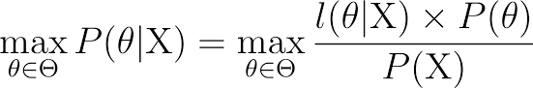
We know that P(X) can be calculated as net integral of X occuring with all possible values of θ,like in below formula of bayes theorem that was explained earlier.
Like P(B) in above diagram is dependent on all values of Aj i.e (A1 , A2…) and not on Ai for P(Ai|B),similarly for P(θi|X) , P(X) is dependent on all values of θ and not on θi.
So,P(X) is constant with respect to a particular θ,therefore while finding θ for maximizing P(θ|X) we cam simply remove P(X) from denominator to make compuation easily solvable.
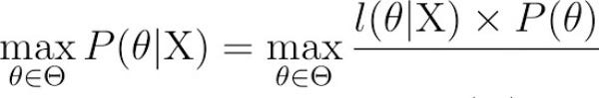
Again,we can write joint probability for likelihood function,express it in product with prior ,take a log ,do partial differentiation to get estimated θ,
